Experiment 12: Creating a Virtual Machine with Specific Hardware Configuration
Aim
To create a Virtual Machine with 1 CPU, 2GB RAM, and 15GB storage using VirtualBox.
Steps
- Open VirtualBox and click New.
- Enter VM name and select OS type/version.
- Set Memory Size = 2048 MB (2GB).
- Select Create a virtual hard disk now.
- Choose VDI (VirtualBox Disk Image).
- Select Dynamically Allocated storage.
- Set disk size to 15GB.
- Go to Settings → System → Processor.
- Set CPU count = 1.
- Save settings and start the VM.
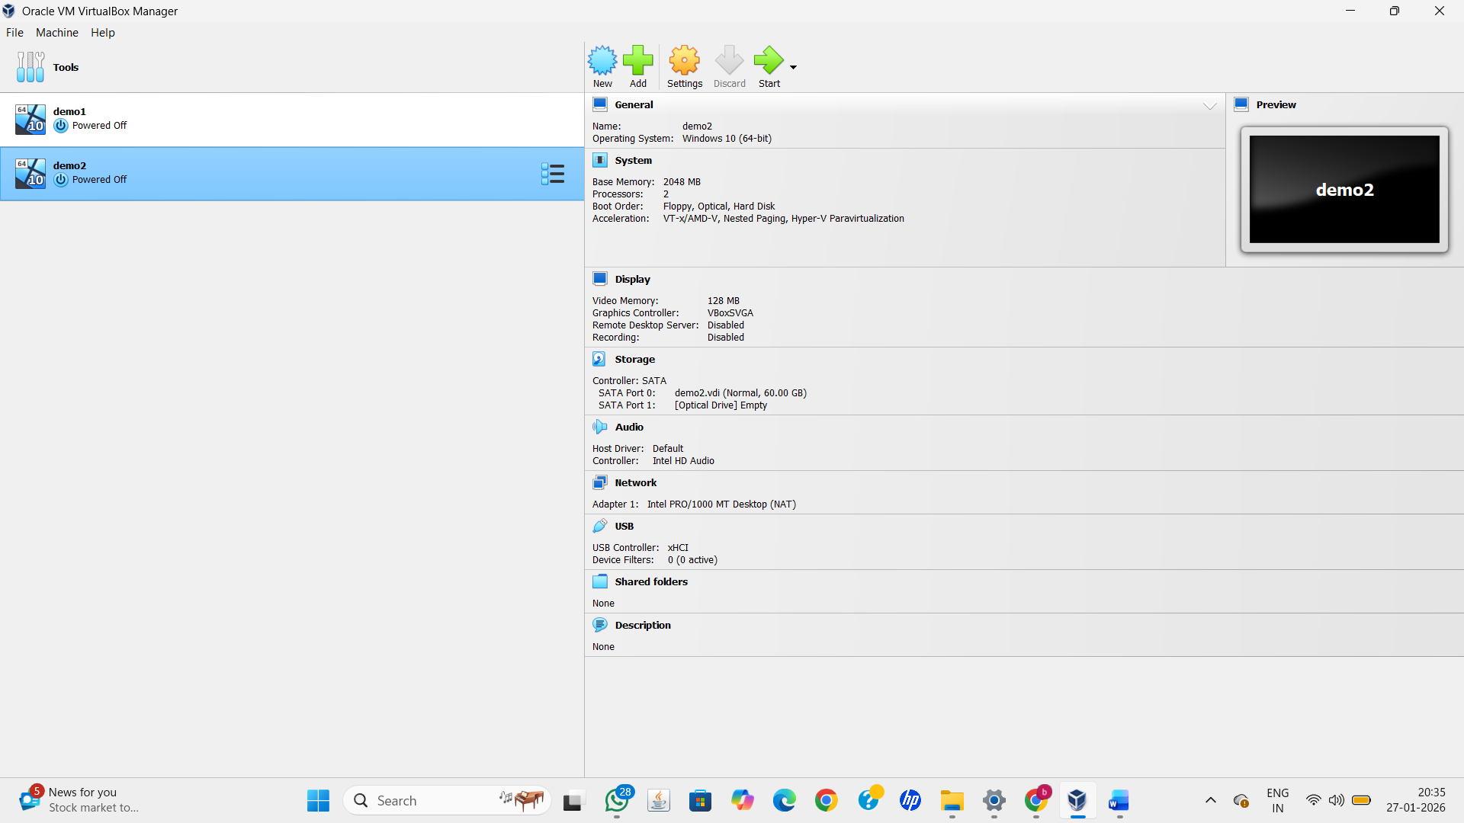
Result
A Virtual Machine was successfully created with 1 CPU, 2GB RAM, and 15GB storage.

